Operating Systems – 2
Report
Assignment – 3
EE17BTECH11041
Sumanth Reddy Cherupally

The output of the program demonstrates the following properties:
- a producer thread produces items only when there is sufficient space left in the buffer.
- a consumer thread consumes only those items that are indeed produced by a consumer thread.
Following are the values of avg waiting time(sec) for corresponding ratio of up/un:
up/uc=[10,8,6,4,2,1,0.8,0.6,0.4,0.2,0.1]

lock_producer=[0.89,0.72,0.68,0.56,0.55,0.57,0.52,0.51,0.50,0.49,0.49]
lock_consumer=[7.81,6.66,5.3,3.66,1.78,1.15,1.12,1.13,1.01,0.97,0.93]
sem_producer=[1.59,1.43,1.21,1.05,0.668,0.59,0.55,0.54,0.55,0.56,0.57]
sem_consumer=[5.59,4.03,3.11,2.14,1.32,1.07,0.96,0.90,0.89,0.94,0.92]
These values were obtained by running several simulation of each value of up/uc.

The graph looks like this:
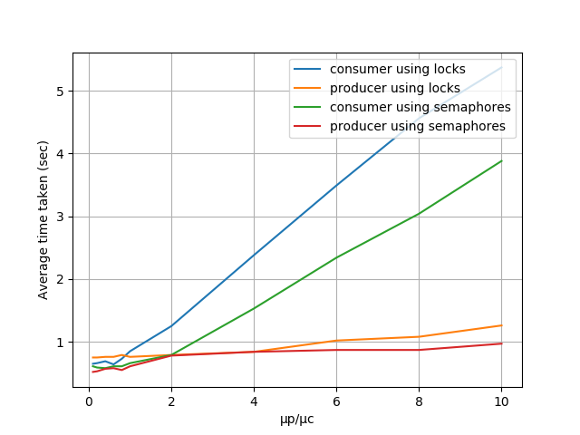
First thing we can see that producers take less time than consumers in any kind of implementation, except when ratio up/uc is very small they tend to become very close to each other. This is because the consumer can only consume a producer produces an item in the buffer. There will be instances where the consumer will have to wait for the producer to produce. Also in the input test case we have more consumers than producers so waiting time of consumers will further be increased.
Now we can notice that consumer and producer using locks were taking significantly more time than the ones using semaphores. We can see this clearly when up/uc is is increasing. This is because semaphores are more efficient than mutex locks and the time taken to aquire and release the lock gives significant difference in their performance.

